# Assignment Submission

## Coding for Designers, Managers, and Entrepreneurs I

Chris Harwood

# 

# Part 1: User Stories

## User Stories

**Epic 1** - Create pages for each menu option on the home page (index): **As a** technician, **I want to** be able to navigate to any menu option shown on the home page **so that** I can leverage all functional options this site has to offer me to perform my job as effectively and efficiently as possible.

* *Story 1*: **As a** technician, **I want** each page to look similar to the Main/Home (index) page **so that** I know I’m still on the HinH website
* *Story 2:* **As a** multi-page website, **I want** the menu option for the page the user is on to be in red text **so that** users know which page they’re on.
* *Story 3:* **As a** technician, **I want** to be able to access options/pages by clicking menu options **so that** I can intuitively navigate between pages.

**Epic 2** - Create a Help page for the technicians: **As a** technician, **I want to** have the option to open a Help page **so that** I can get help doing my job, including using the website, if needed.

* *Story 1:* **As a** technician, **I want** the Help page to be structured in the process ‘order’ **so that** I can quickly find help based on where I’m at in the company’s Work Order process.
* *Story 2:* **As a** technician, **I want** the content of Process Step 5 – Order Replacement Parts to display **so that** I can use the site as efficiently and effectively as possible
  + *Note: This story is temporary until content for each step is published*

**Epic 3** – Create a Part Details page**: As a** technician, **I want** the option to click a part and open a page containing part details **so that** I can ensure I order the correct part.

* *Story 1:* **As a** technician, **I want** the Part Details page to contain all part-related information including description and technical specifications **so that** I can ensure I have the right part, that it will fit, and so I can communicate the price and turn-around time to my customer.
* *Story 2:* **As a** technician, **I want** a button available to initiate an order for the part shown **so that** I can efficiently keep the repair process moving forward.

**Epic 4** – Create a Search page**: As a** technician, **I want** the ability to search the parts database and click a resulting part to open a Part Detail page **so that** I can quickly find the part I’m looking for.

* *Note: this functionality will be added once prior Epic prototypes are approved (i.e. not part of this project)*

# Part 2: Prototypes (OPTIONAL)

## Prototype

Epic 2

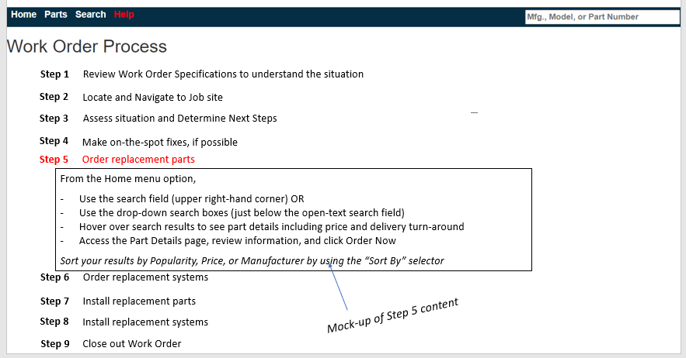

## 

## Notes on Epic 2:

* The 9 steps shown represent the current Work Order process followed by HVAC in a Hurry Field Technicians. Currently, there is content on Step 5 only, to help users order replacement parts.
* As more content is made available, each Step will be clickable, displaying its content, and making the Step # turn red, when clicked. When clicked again (or another step is clicked), the detailed content will disappear and the Step # will no longer be red.

## Prototype

Epic 3

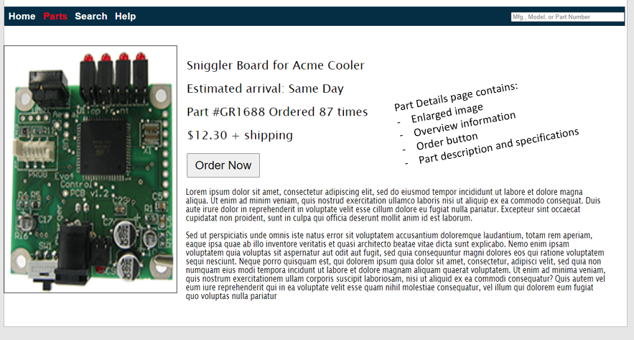

## Notes on Epic 3:

* This mock-up shows what would be displayed to the user after clicking on the Sniggler Board for Acme Cooler link from the Home/Search page. On the prototype site, this is displayed by clicking on the “Parts” menu option.

# Part 3: Links to JS Fiddle

## Links to ~~JS Fiddle(s)~~ Github

<https://mnchsplat.github.io/Coding-for-MGRs/index.html>

Note – my solution requires 4 html files (index, search, help, part_details), so instead of JSFiddle, have uploaded them to my Github site. The URL provided will present my complete solution for this course, supporting the Epics and user stories, above.